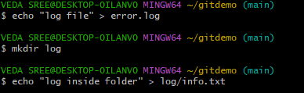
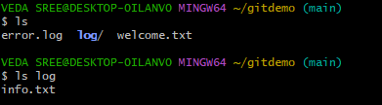
2. Git Ignore
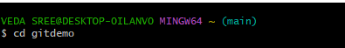
1. move to project folder

2. create a folder to ignore and add file in to it and check over comments

3. create .gitignore
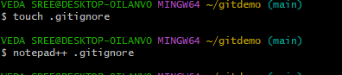

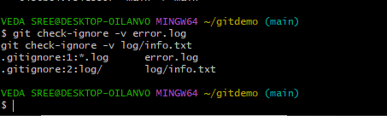
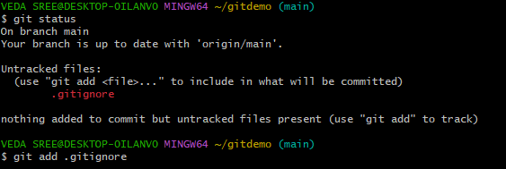
4. check status

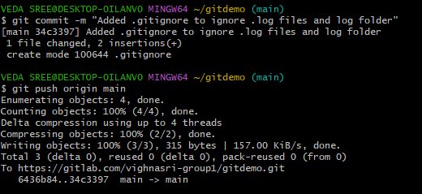
5. commit to gitlab

